(1)Screws are indispensable industrial essentials in daily life: such as cameras, glasses, clocks, electronics, etc;General screws for televisions, electrical appliances, musical instruments, furniture, etc;For engineering, construction, and bridges, use large screws and nuts;Traffic appliances, airplanes, trams, cars, etc.
More than ten years of hard work, our strength in China has been ranked in the top three.Our products are sold at home and abroad and are welcomed by domestic and foreign customers.We cooperate with many famous brands,such as Xiaomi, Huawei,OPPO, Vivo, Lenovo, Meizu and so on.This product name is Aluminum galvanized phillips machine screw.Its raw material is aluminum,the surface is galvanized,the color is blue, and the color can be set according to customer needs,head shape is cross recessed. In addition, this product can be used in home appliances, kitchen appliances, computers, notebooks,a wide range of uses.We have the advantage of being able to customize the product.
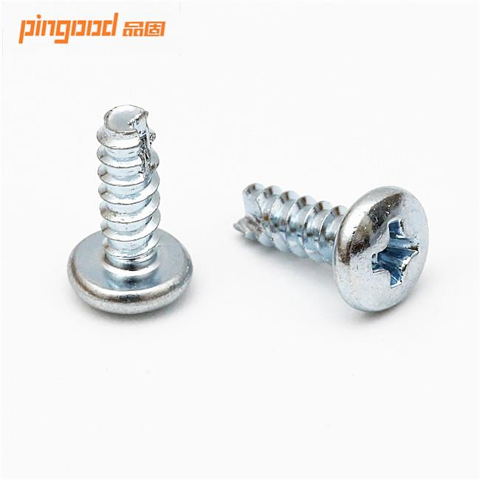
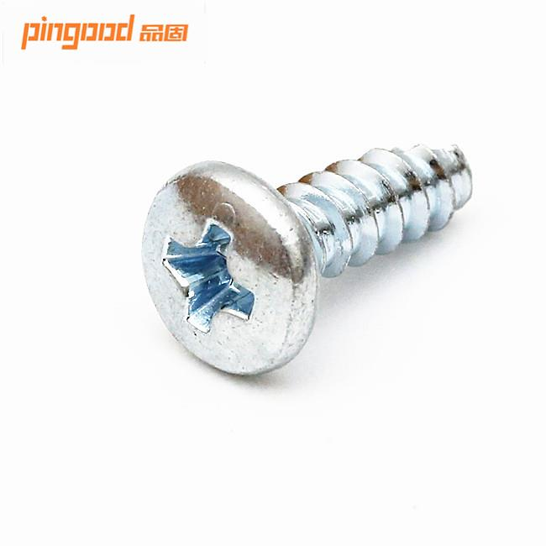 ;
(2)Product Description
Material:Stainless Steel,Steel,Carbon steel,Aluminum or Aluminum Alloy,Brass or brass alloy
Size:According to customer requirements
Head shapes:Pan Head, Flat Head, Undercut Flat Head , Oval Head, Truss Head, Button Head, Cheese Head, Hex Head, Cap Head, Binder Head, Hex Washer Head
Standard:ISO, DIN, ANSI, JIS, BS , Non-standard and etc
After Sales Service:We will follow up goods quality and shipment for every customer ,and help solve problem after sales one by one. Any customer complaints, pls send email or by call me at 86-136 625 923 15
Finish:Plain, Zinc Plated, Black oxide, Nickel, Chrome, H.D.G and etc
Used:Widely Used
Company URL:www.pin-good.com
(3)More Products
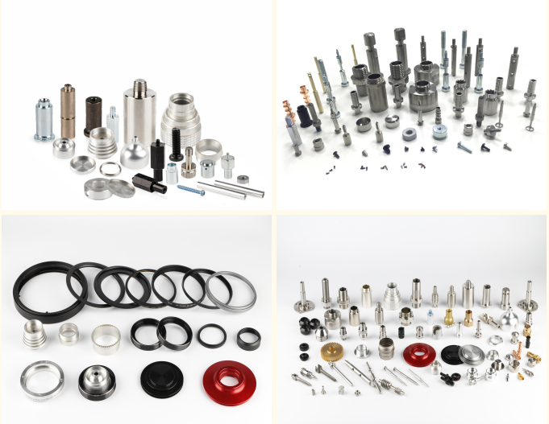
(4)Our Company
Our factory is located in Dongguan, Guangdong Province,we also set up our own foreign trade department.We have professional engineers and foreign trade teams.We use advanced machines for production and professional personnel to test to ensure product quality.
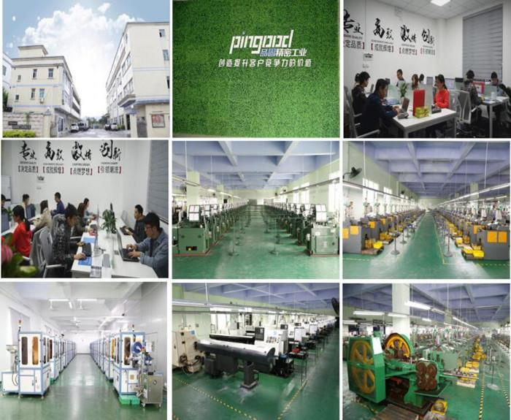
(5)Our Certificates & Partners
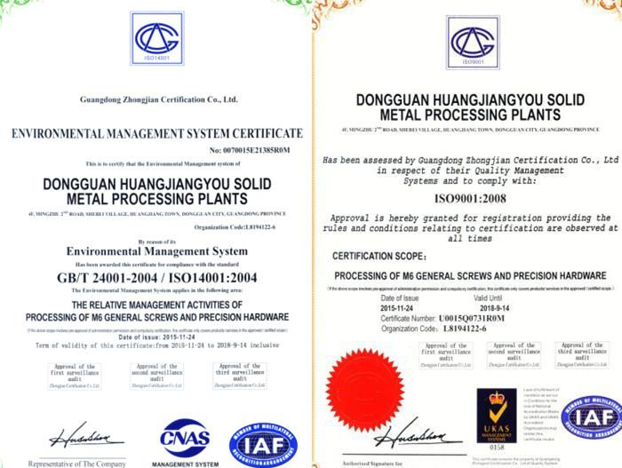
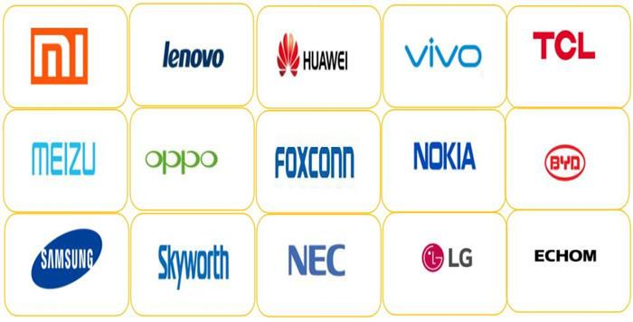
(6)Trade & Market
We have stable customers at home and abroad,Domestic Market and North America account for 20%,Northern Europe and Eastern Europe account for 10%,other places such as the South America occupy different proportions.In addition, product quality is praised by customers.
(7)Production Process
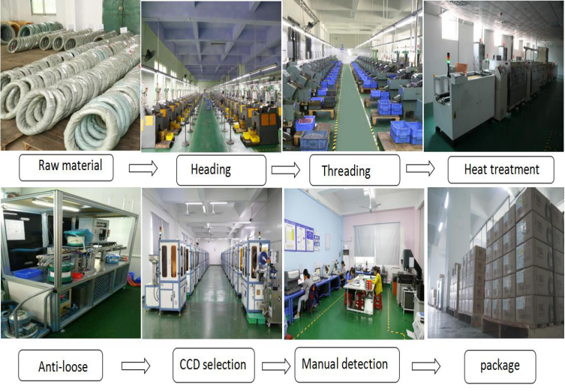
(8)Testing Equipment
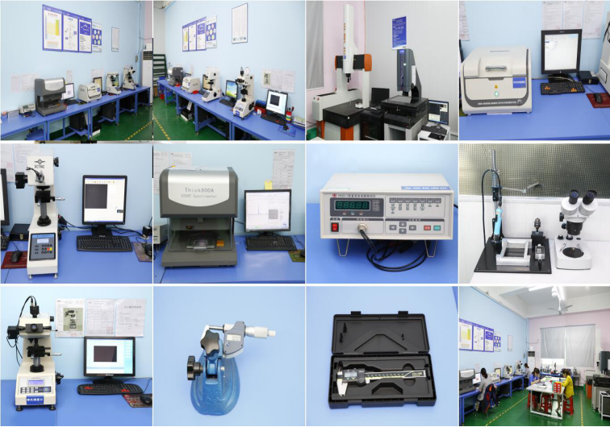
(9)Packing & Delivery
We can provide a variety of transportation methods, or according to customer requirements.Transportation options are available:
1. Plastic film & kraft paper packing
2. Plastic bag packing
3. Plywood board packing
4. Wood box packing
5. Pallet packing
6. Bundle packing
7. As per customer's requirement
(10)our service
1.We have gained more than ten years experience in research, development and manufacture of the fasteners, and have more professional technical staff for design and quality control, Especially served Xiaomi, TCL, Huawei, Foxconn, Samsung famous top group. There are 70 sets advanced production equipment and more quality control tools for ensuring 100% satisfation from our customer.
2.We can provide all kinds of international certificates such as ISO 9001 certificate, etc. All our products have to pass four inspections. Firstly, pre-production material inspection; Secondly, professional inspection by QC; Thirdly, salesman casual inspection and the third party inspection or customer inspection. Our sales are almost 24hours available online, providing best before-sale and after-sale service.
(11)FAQ
1.Are you trading company or manufacturer?
We are factory.
2. How do you control your quality?
We have test equipment, such salt spray text, bolt torque test and so on. And we can provide you material test certificate of the goods when it is finished.
3. Do you accept small order?
Sure, we can accept any orders.
4.What will you do for after sales?
When our metal parts apply to your products, we will follow up and await you feedback. Any question related to our metal parts, our experienced engineers are ready to help.
(12)Contact:
Contact:lisa Wang
Email:lisa@pin-good.com
Wechat:136 625 923 15
Tel:86-136 625 923 15
(13)We can meet the various needs of our customers and customize products according to customer needs.The production process is raw materials, heading, threading, heat treatment, plating, anti-loose, CCD selection, manual and machine detection,and finally shipping.Inspection equipment has ROHS, quadratic element, three-D, salt spray test, etc.
Packaging can also be based on customer needs.

